Activity sheet
Statistics – migration in Australia
1. Read Face the Facts – Questions and Answers about Migrants and Multiculturalism to gather facts about migration and multiculturalism. After you have finished reading, answer the questions below.
How many people migrate to Australia?
Explore Question 2.1 – How many people migrate to Australia to gather the facts.
Where do migrants come from? Identify the main countries of origin in 2007–08. Gather statistics to back up your answer.
Who can migrate? Identify the categories which migrants can enter Australia under? Use Question 2.3 – Who can migrate? to gather the facts.
2. Create a series of charts and tables to illustrate the statistics you have identified. Use a graphics package to present your statistics in accessible format which is clear and easy to read.
You must create the following:
- a line chart which illustrates the changes in settler arrivals in Australia from 1998–2008
- a pie chart which illustrates the percentages of religious identification in Australia in the 2006 census

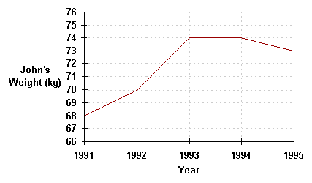
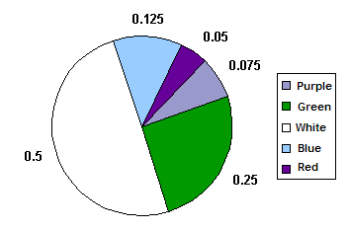

Example of a line chart Example of a pie chart
3a. How diverse are Australians? Identify the percentage of Australia’s population born overseas based on statistics in the 2006 census.
Write down one of the three most common ancestries that people identified. Explore Face the Facts – Questions and Answers about Migrants and Multiculturalism to gather statistics to back up your answer.
....................................................................................................................................................
....................................................................................................................................................
3b. Conduct a diversity survey in your classroom to explore the origins of your classmates and their families. Your survey could include the following questions:
1. Where were you born?
2. Where was your mother born?
3. Where was your father born?
4. Where were your grandparents born?
5. Do you or members of your family speak languages other than English at home?
You may also wish to include questions in your survey which record the ages of your classmates and their families when they migrated to Australia; the dates your classmates or their families migrated to Australia; or the reasons your classmates or their families migrated to Australia.
4. Collate the data you have gathered during your survey and create a series of charts or tables to illustrate your findings (on graph paper), including:
- the main countries your classmates’ were born in;
- the main countries your classmates’ parents were born in;
- the main countries your classmates’ grandparents were born in; and
- the main languages your classmates’ speak at home. Select the best format to represent the information you are communicating in a clear and useful manner.
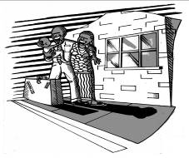
5. Report back to the class on your findings. Compare the findings of each group with the statistics in Face the Facts – Questions about Migrants and Multiculturalism.

